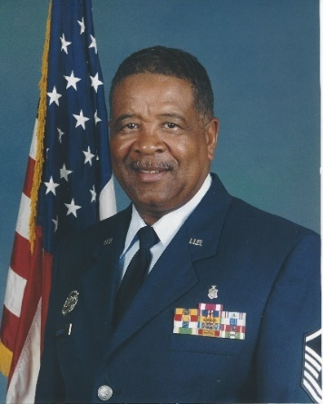

Master Sergeant James Edward Barrier III – Service

Master Sergeant Barrier III began his military career in the United States Air Force in 1967. A Vietnam Veteran who served as a Parachute Rigger, Air Traffic Operator and Pharmacy Technician. He also served nine years of foreign service as a member of the United States Air Force. After his retirement from the Air Force, he continued serving by volunteering and mentoring young people in his local community by working in the Cabarrus County School System for 23 years as a JROTC instructor and a Boy Scout Leader and has continue working in scouting to this present day. He was awarded the USAF JROTC Outstanding Instructor Award, The Boy Scouts of America’s District Award of Merit, and was appointed 04-02 precinct Chief Judge by the Cabarrus County Board of Elections, therefore fulfilling his civic duty.

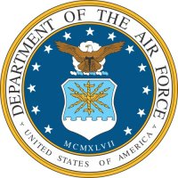
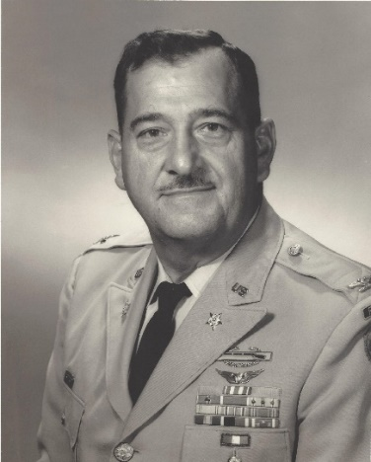
Colonel Eugene Conrad - Achievement

Eugene Conrad was born in Charlotte NC. He entered the U.S. Army as a Second Lieutenant form North Carolina State College in October of 1940. He was assigned to the 31st Infantry and sent to Manila, Philippines on 21 April 1941, so he was there during the attack on Pearl Harbor. Eugene was awarded the Silver Star Medal for gallantry in action on 19 January 1942. Enduring grueling fighting, Conrad was wounded three times before his capture on Bataan on 11 April 1942. Forced to go on the infamous Bataan Death March, Conrad survived over three years of Japanese imprisonment, ending at Roko-Roshi prison camp near Tokyo. He credited his survival to prayers for “strength, wisdom and courage.” Eugene served as an instructor at the Ordnance School during the Korean War. He served in Austria and Germany until 1956. At the age of forty-two, he became a dual-rated senior Army aviator. In 1967-68, he was Deputy Commander, First Aviation Brigade in Vietnam. Conrad also served as Director of the U.S. Army Board for Aviation Accident Research, where he developed an 11-point commander’s program that significantly strengthened the Army’s flight safety procedures. In his thirty-two year Army career, Eugene was also awarded the Legion of Merit with Oak leaf cluster, the Bronze Star Medal with two Oak leaf clusters, the Air Medal, the Army Commendation Medal with two Oak leaf clusters, a Purple Heart, and other ribbons. In honor and memory of his achievements, the U.S. Army Safety Center at Fort Rucker, AL was named the Conrad Safety Complex.
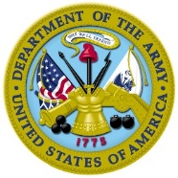
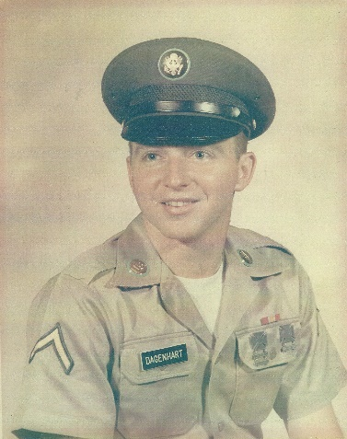

Sergeant Ralph Thomas Dagenhart – Service

Ralph Dagenhart hails from Troutman NC. He went to South Vietnam as a 1st Cavalry Division replacement in the U.S. Army in 1969. Ralph served as a rifleman and as a radio telephone operator. He was involved in over twenty-five combat assaults by helicopter, with one almost ending in disaster, as a fierce mortar barrage and ground assault ensued when the helicopters came to pick up Ralph and the other men who were performing a bomb damage assessment in enemy territory. With two months left in his tour, the Cambodian Incursion was initiated. Dagenhart entered Cambodia on 6 May and eventually discovered one of the largest caches of supplies that was found, with over 1.3 million rounds of ammunition, over 1,000 weapons, vehicles, rice, and medical supplies confiscated. Ralph was awarded the Bronze Star Medal, the Air Medal, and the Army Commendation Medal and his unit received the Army Valorous Unit Award, among others.

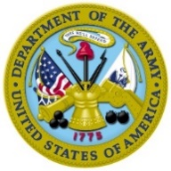
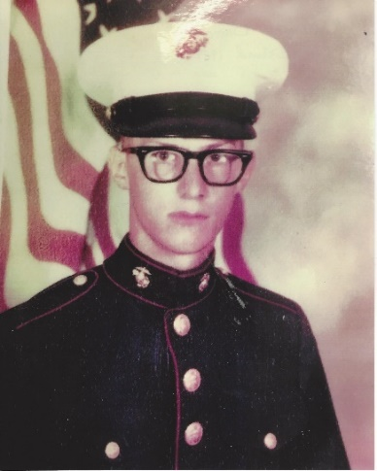

Corporal Dominic Jess Darconte -

Dominic Darconte was born in Rockwell NC. In his senior year of high school, he signed up for the delayed entry program of the U.S. Marine Corps. He attended aircraft maintenance school and spent time in Norway in 1981 training above the arctic circle. He was then trained as a door gunner and assigned to HMM-162 and the 24th MAV in Beirut, Lebanon during the Lebanese Civil War as a peacekeeper. Doninic was awarded the Navy and Marine Corps Achievement Medal for going above and beyond the call of duty to repair a badly damaged aircraft. While living at the Beirut Airport, Darconte’s unit was shelled with RPGs and small arms fire. A grenade hit close to him and the blast threw him and injured his knees. After a terrorist drove a truck with explosives through a building housing Marines, Dominic’s duty was to fly the wounded to the USS Iwo Jima for emergency medical treatment. Dominic received the Combat Action Ribbon for his Beirut service, among other medals.

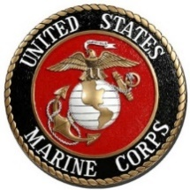
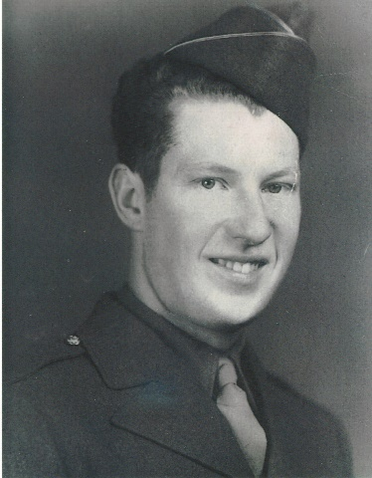

Corporal James Deal - Service

James (Jim) Gilbert Deal was working in a cotton mill in Cooleemee NC when he was drafted into the U.S. Army in 1942 at age eighteen. At Fort Bragg NC he joined the 737th Tank Battalion of General George Patton’s Third Army as a gunner. When he went overseas in February of 1944, Jim participated in the campaigns of Northern France, Normandy, Rhineland, and Central Europe, and earned a Good Conduct Medal. By 21 February 1945, the area where Jim was patrolling had been clear of German activity for some time and so the men were not on high alert. Jim and a good friend had dismounted from their tank and were searching for some small trees on which they could string up a tarp from their tank and create a shelter for their bedrolls. Unexpectedly, Jim engaged a trip wire attached to a German mine, which exploded. Shrapnel pierced both his thighs, going completely through both legs and then lodging in a tree beside of him. After spending the night in a nearby field hospital, Jim was taken to a hospital in England, where he would undergo surgery. After the war, Jim worked for Norfolk Southern Railway in Spencer NC. He has been a member of the Faith American Legion for over seventy years and recently attended the 71st 737th Tank Battalion Reunion.

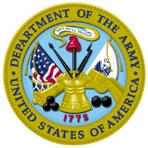
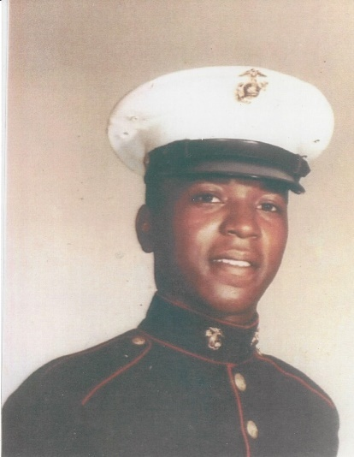

Corporal Jackie Drakeford - Valor

Jackie Drakeford, a native of Kershaw SC, enlisted in the U.S. Marine Corps in December of 1965 in Charlotte NC. He was assigned to Echo Company, 2nd Battalion, 3rd Marines and stepped into a constant series of patrols and ambushes when he arrived in Vietnam. Armed with an M-16 that frequently jammed, Jackie was often forced to fight with rocks, sticks, and knives. Wounded himself, he was the only squad leader left after a Battalion of North Vietnamese attacked his platoon. He spent nineteen months in combat, including the first defense of Ke Sanh and the bloody “Hill Fights.” Jackie received a Purple Heart with two gold stars for shrapnel wounds in both arms and his left leg, received on 3 May 1967, 23 May 1967, after which he was medevaced to the USS Princeton, returning to his duties as squad leader on 10 June. In addition to other medals, Jackie was awarded the National Defense Service Medal and the Navy Commendation Medal with combat “V.”

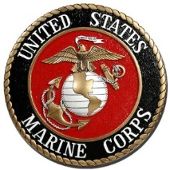

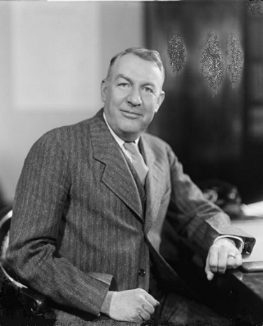

Private Samuel Irvin Jr. - Valor

Samuel James Ervin was born in Morganton NC in 1896. He attended the University of North Carolina from 1913 to 1917 and volunteered for the U.S. Army in May of 1917. Samuel served eighteen months in Company I, 28th Infantry Regiment, 1st Division of the American Expeditionary Forces. He received the Silver Star medal for gallantry in action during the capture and defense of Cantigny, France in May 1918. He led a carrying party on several trips from the rear to the front until he was wounded. He received the Distinguished Service Cross for his actions on 9 July 1918. That day, he was hit by a shell fragment as he fearlessly led a platoon that had lost its leader. He led volunteers in the face of direct fire in a charge on a machine-gun nest. He fell wounded in front of the gun pit, but his party seized the gun. Samuel crawled to their original position and organized a rifle post, refusing to be evacuated until the other men were safe. He received the Purple Heart and the French Fourragere for his courageous actions. After the war, Samuel served North Carolina as an attorney and his country as a U.S. Senator for twenty years, during which time he chaired the “Watergate Committee.”

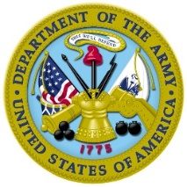
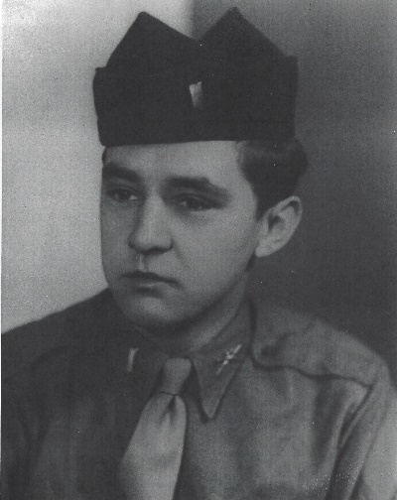

1st Lieutenant Cecil Fisher - Service

Born in Rockwell, NC, Cecil Fisher was inducted into the U.S. Army in December of 1942. Cecil served as a Technical Sergeant in the 30th Infantry in the European Theater and earned the Good Conduct Medal and Combat Infantryman Badge as he led his platoon in the campaigns of Naples-Foggia, Rome-Arno, Southern France, the Rhineland, and Central Europe. The end of September, 1944, found Cecil in heavy fighting in the Vosges Mountains of France. Well-defended by the enemy, the mountainous terrain and bitter cold made the U.S. advance difficult, but Cecil’s division fought onward, over mountain after mountain. Then on the first of October, Cecil was wounded in action and earned the Purple Heart medal. On 14 March 1945, he accepted a commission as a Second Lieutenant and served as Infantry Unit Commander. Cecil earned five bronze service stars and two arrowheads (for amphibious assault landings) on his EAME ribbon, the Army Occupation Medal (Germany), the French Fourregere, and his unit received three Presidential Unit Citations. Cecil later went on to serve in the Korean War as well.

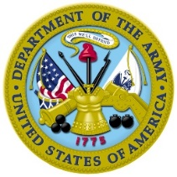
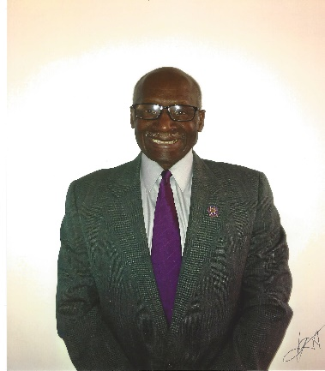

Master Sergeant Roosevelt Gary - Service

Roosevelt Gary resides in Charlotte NC. He earned a Master’s Degree from Central Michigan University and offered twenty-one years of service to the U.S. Army and became a Master Parachutist with over 200 parachute jumps. His key skills were in counterintelligence and counterespionage methods in Vietnam from November 1966 to October 1967, assigned to the Military Assistance Command (MACU) and as Advisor to the 7th Army Republic Vietnam (ARVIN) Division and the 7th Ranger Battalion, Republic of Vietnam. As the Assistant Tactical Operation Center Officer, he requested all air and naval gun support for missions. Roosevelt participated in over twenty-five hours of sustained aerial flights over hostile territory in support of ground combat, for which he received the Air Medal. From 1970-73, he was assigned as Operation/CI Agent with the 610th MID, 5th Special Forces, 470th MI Group in the Panama Canal Zone and he helped with disaster relief operations in Nicaragua as an MSG/CI Agent, he provided civilian protection during Army expeditions in Lebanon and the Dominican Republic. Gary received numerous commendations from the Defense Investigative Service. He has held many positions in the community and in national and professional organizations since his military service, and has volunteered in the Mecklenburg School System.

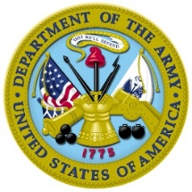

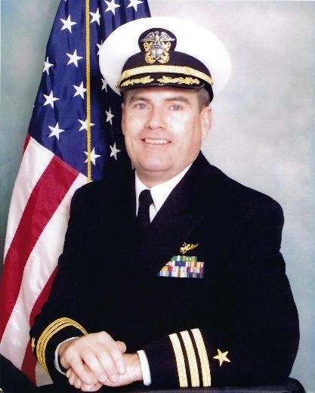

Captain Mark Gibbons – Service

Mark Gibbons lives in Huntersville NC. He initially served as an enlisted marine for four years and left to pursue a career as a Navy aviator. From 1990 to 2003, he flew numerous missions in support of Operation Desert Storm in forward-deployed areas such as the Congo, Saudi Arabia, Kuwait, Bahrain, Qatar, and Djibouti. Leaving active duty in 1998, he remained in the Navy Reserve and was deployed in Operation enduring Freedom. Since, Mark has worked tirelessly to serve those in need in his community. While working full time as a corporate pilot, Gibbons has volunteered as a religious teacher, at the Angels and Sparrows soup kitchen, and for Room in the Inn. He worked for support for the VA Accountability Act with Concerned Veterans for America and served as Finance Officer at American Legion Post 321. Mark is on the Mecklenburg County Veterans Council and an active member of the Marine Corps League Detachment 1242. In 2014, Mark was Co-founder and board member of Widen 77, a nonprofit that educated the public on the long-term effects of managed lanes in I-77. In 2015, Mark was elected to the Huntersville Board of Commissioners. He is now in his second term.

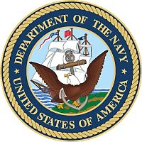
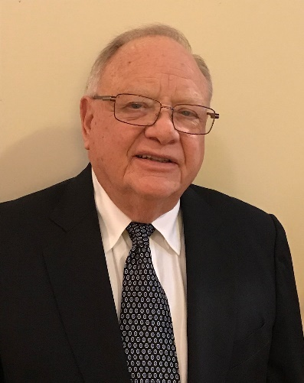

Captain Robert William Gorman - Valor

Robert Gorman was born in Philadelphia PA and attended Drexel University. After training other soldiers for their tour of duty in Vietnam, in January of 1968, Robert was transferred to the 4th Battalion, 47th Infantry, 9th Infantry Division in Vietnam. He served as Infantry Platoon leader for a year in the Mekong Delta in almost continuous combat. He worked closely with the U.S. Navy as part of the Army’s Elite Riverine Force and faced hostile situations in beach assault landings. He received the Bronze Star Medal with “V” device for heroism in ground combat on a reconnaissance inforce mission in Dinh Tong Providence on 23 April 1968. The platoon came under heavy rocket fire and Gorman led his men in an assault against the enemy bunkers, destroying hostile enemy positions. Robert also received the Air Medal for participating in more than twenty-five aerial missions over hostile territory. Gorman stayed in the Army Reserve upon returning to the States.

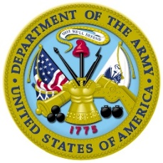

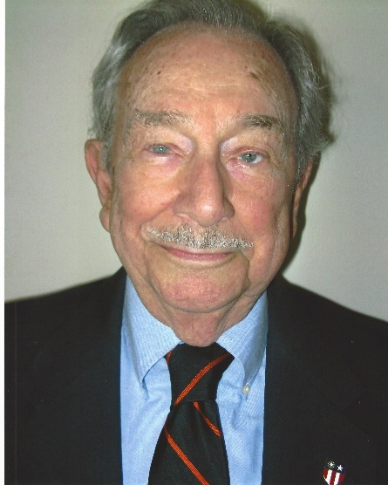

Corporal Thomas Harrell Jr – Service

Thomas Harrell served during World War II in the U.S. Army Air Corps Air Transport Command in the China-Burma-India Theater from 1943 to 1946. A resident of North Carolina since 1951, he owned and managed radio stations WSTP and WRPX in Salisbury for forty years. He was instrumental in founding Welcome Home Veterans as a non-profit veteran’s coffee shop in Mooresville in 1995, thus protecting the military memorabilia which veterans had donated to the coffee shop. In 2014 he assisted in opening the Frontier Coffee Shop in Salisbury and since then has been sought out by those wishing to open a coffee shop for veterans. Thomas served five terms on the Board of Directors of the Rowan County Chamber of Commerce and has served on the planning boards of both Rowan County and the City of Salisbury. He was a founding member of the Salisbury Symphony and the Piedmont Players Theater. In 2017, at age 92, Thomas was awarded the Order of the Longleaf Pine, the highest civilian honor given by the state of North Carolina, honoring his many decades of service.

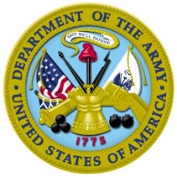

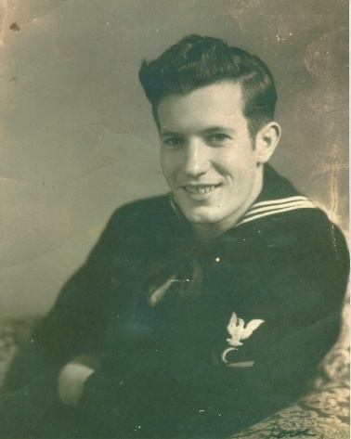

Sergeant First Class Robert Doyle Hartman – Service

Born in Salisbury NC, Robert Doyle Hartman served as a cook in the U.S. military – first in World War II in the Navy, and then in Korea in the Army. In his Navy service, Robert sailed on the USS Horace A. Bass APD 124 in the Okinawan campaign, where the destroyer took a kamikaze hit with the loss of fourteen men. As a member of the Tokyo Bay Occupation Force, Robert participated in the capture of HIJMS Nagato, an act which symbolized the unconditional and complete surrender of the Japanese Navy. While onboard the Nagato, he took a Rear Admiral flag from the vessel, which his daughter recently donated to the Pearl Harbor Historic Site museum. In Korea, Robert was part of the 575th Engineer Construction Battalion in the Third Army, where he achieved the rank of Sergeant and was a battalion cook. Robert passed away in 1999.

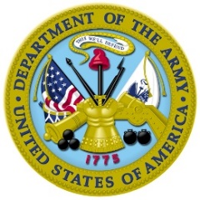
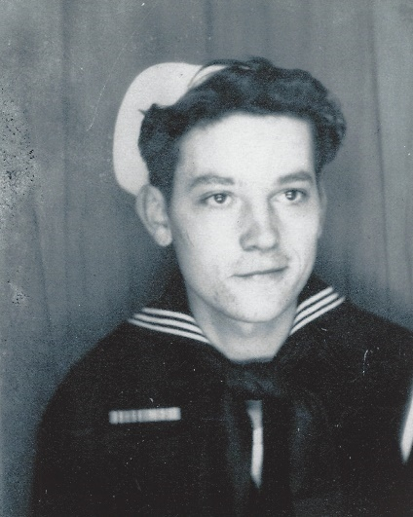

Seaman First Class William George Hill – Service

William (Bill) George Hill was born in Kannapolis NC. He was employed by the York Yarn Mill in York SC when he entered the U.S. Navy in February of 1943, just before his eighteenth birthday. Assigned to the USS Kimberly DD-521, he served as both a gunner and a baker. On a week-long furlough after basic training, he came home and married his girlfriend before he shipped out. Bill engaged the enemy in the Gilbert Islands and later in the campaign for Okinawa. He also received a service star for participating in the liberation of the Philippines. In March of 1945, the destroyer Kimberly was attacked by two enemy planes. A kamikaze pilot crashed into the aft gun mounts killing nine men and wounding thirty-three, with eighteen missing. The suicide plane became hung-up on the destroyer’s side for a time before it was released into the ocean. On 4 September in Tokyo Bay, Bill and the crew were witnesses to the signing of the Japanese surrender on the USS Missouri. Two days later, the Kimberly escorted the Missouri back to the U.S. Bill and his wife worked in the textile industry and raised their family in Gaston County, NC after the war. Bill has visited every state in the Union and traveled with his denomination’s mission group.

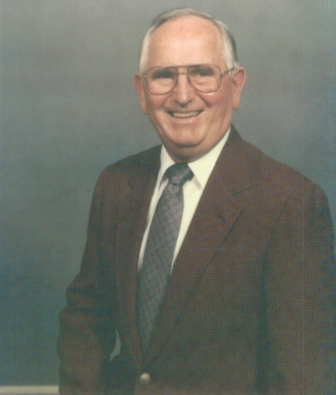

Seaman First Class Glen Clive Hoffner - Service

Glenn Hoffner was born in Mt. Ulla NC. He entered active service in July of 1944 and served on LST-966 and LST-1061. He supported the amphibious operations by carrying tanks, mechanized vehicles, supplies, cargo, small landing craft, and troops from ship to shore. After a stopover at Pearl Harbor, he sailed to Guam, Saipan, and Tinian in the Mariana Islands, then on to Okinawa. When under enemy fire, Glenn manned his gunnery position at the front turret. On 10 September 1945, his LST rode out Typhoon Ida – the strongest typhoon to hit Kyushu on record – and missed being part of the destruction in Buckner Bay, Okinawa.

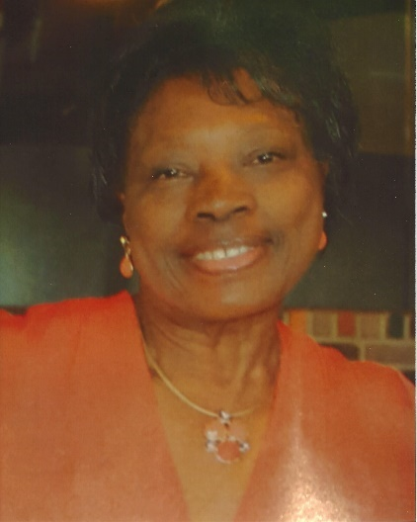

Staff Sergeant Thelma Luckey - Service

Thelma Luckey of Salisbury NC is a twenty-one year veteran of the U.S. Army Reserve of the 846th Transportation Company Cargo Unit./ Ms. Luckey was the first woman to enlist in this unit. Thelma began her cooking career in Spencer NC at a restaurant where she was employed for twenty-eight years. After graduating from Salisbury Business College, she had plans of opening her own restaurant, but these plans were delayed when her Reserve unit was called up for active duty during Desert Storm in 1991. Thelma’s Down-Home Cooking opened in August of 2009 in in Salisbury Mall. A second store was opened in Mooresville and a third in downtown Salisbury in 2017. Luckey hosts an annual Veterans Appreciation Dinner. Her Frontier Coffee Shop hosts a weekly gathering of veterans with coffee and pastries offered at no charge. She also provides food and beverages in cooperation with the Red Cross to our first responders.

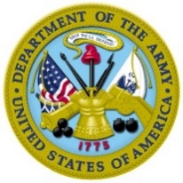
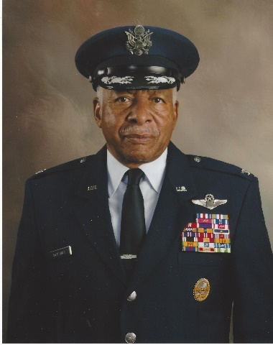

Colonel Normal Alexander McDaniel - Valor

Norman McDaniel, who now resides in Burlington NC, served on active duty in the U.S. Air Force for over twenty-eight years. His career included serving as a B-52G aircraft combat crewmember; a subsystems manager for the F-111 aircraft development program; an EB-66C aircraft combat crewmember; as the USAF Survival Training Wing Commander; and as a Staff Officer in the Office of the Secretary of Defense. When flying combat missions in Vietnam, Norman was shot down by a surface-to-air missile. He endured six and a half years of torture and deprivation by the enemy, but resisted valiantly. He received the Distinguished Flying Cross for participating in an extremely hazardous aerial flight over North Vietnam on 5 July 1966 with professionalism and courage in the face of hostile fire. Norman was awarded the Silver Star medal and the Air Force Commendation medal for gallantry in resisting the mental and physical cruelties the enemy used to try to extract information from him. After his release from prison camp in 1973, Norman served in the USAF for fourteen more years. Upon his retirement, Norman was Leadership and Management Professor, Department Chairman, and Associate Dean at the Defense Acquisition University and now offers motivational speaking to groups.

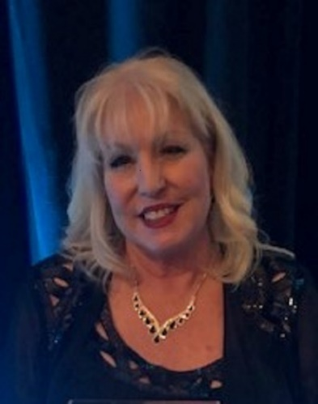

Technical Sergeant Susan Smith-McEntire - Service

Susan McEntire has resided in Charlotte NC since 1966. She devoted herself to twenty-one years of military service in the U.S. Army National Guard, becoming one of the first females in North Carolina to enlist in the Guard in the 113th Field Artillery Unit at Charlotte Douglas Airport. She served there until 1977, when she transferred to the North Carolina Air National Guard, becoming the first female to join the Flying Squadron. While there, she served as chairman of the Time and Place Committee for the North Carolina National Guard Association. In 2009, Susan received a Certificate of Appreciation from the Medal of Honor Society for her service and work in the military community. She served as President of the NCANG Alumni Association and is still currently a board member. Susan also worked to get Charlotte Motor Speedway designated as the first Purple Heart Speedway.

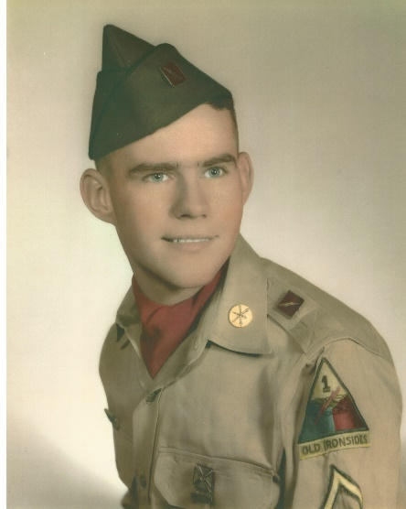

Private First-Class John O’Conner – Service

Upon returning to New York, John became very active in various non-profit organizations. On August 24, 1968 he served as Chairman of an Elk committee that support the “Boys of Vietnam” and dedicated at plaque to all Vietnam veterans that died in combat. In 1975, he helped to form the Sussex County Militia to re-enact the Revolutionary Battles for the Bicentennial. While doing the re-enactment of the Battle of Yorktown, John was chosen to be inspected by President Ronald Reagan and President Mittarand of France. O’Conner also served Veterans, teen girls and their babies who were raped by drug addicts who carried the HIV virus. John worked on “AIDS Rides Across America” with Elizabeth Taylor and Ivana Trump in New Jersey.

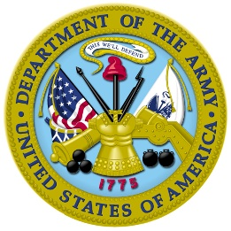

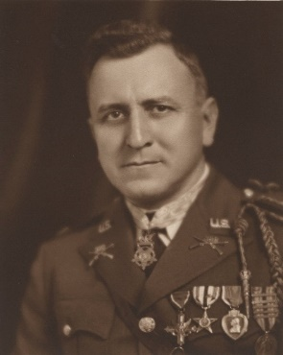

First Lieutenant Samuel Iredell Parker - Valor

Samuel “Si” Parker was born in Monroe NC. In World War I, he fought with the 28th Infantry, 1st Division, American Expeditionary Forces. On 18-19 July 1918, near Soissons, France, when fighting with Company K, Samuel displayed conspicuous gallantry and intrepidity above and beyond the call of duty. A gap appeared in a frontline position between the left flank of the 28th and the French 153rd Division. This exposed the left flank of the 28th to a terrific enfilade fire from enemy machine guns. Samuel ordered what was left of his platoon and a group of French Colonials to join him as he ran through direct enemy rifle and machine gun fire to the crest of a hill, and rushing forward, took a rock quarry enemy position by storm, capturing six machine guns and forty prisoners. The next day, although painfully wounded in the foot, he refused to be evacuated and continued to lead his command until the objective was reached. He had to crawl on his hands and knees to consolidate the battle line due to his painful wound. His gallantry and spirit of self-sacrifice were a source of great inspiration to the entire command. For this action, he was awarded the Medal of Honor. On 5 October 1918, when near Exermont, France, Samuel displayed extraordinary heroism in action when, with total disregard for his own person danger, he advanced directly on a machine-gun 150 yards away while the enemy was firing directly at him. He killed the gunner with his pistol. Only a few men of the platoon were left, and they were almost surrounded by the enemy, but they continued to fight until other troops came to their aid. For this action, Samuel was awarded the Distinguished Service Cross. He also received the Silver Star medal and the Purple Heart.
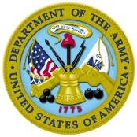
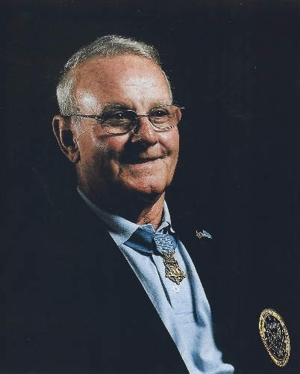

Command Sergeant Major Robert Martin Patterson
Medal of Honor

As of 2019, Robert Patterson is the only living Medal of Honor recipient to be born in North Carolina. Robert received the medal for his actions near La Chu, Vietnam on 6 May 1968. He was a fire team leader of the 3rd Platoon, Troop B in an assault against a North Vietnamese Army battalion, which was entrenched in a heavily fortified position. When the leading squad was pinned down by weapon and rocket propelled grenade fire, Patterson and other members of his assault team moved forward under a hail of enemy fire to destroy the bunkers sheltering the enemy. Observing other fire on his comrades, Robert, with complete disregard for his safety, assaulted a bunker complex. Although exposed to intensive small arm and grenade fire, Patterson single-handedly destroyed five enemy bunkers, killed eight enemy soldiers, and captured seven weapons. His dauntless courage and heroism inspired his platoon to resume the attack and penetrate the enemy’s defensive position. In addition to the Medal of Honor, Robert received the Bronze Star Medal, the Legion of Merit, a Purple Heart with two Oak leaves and other awards.

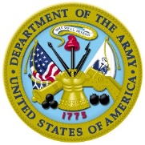
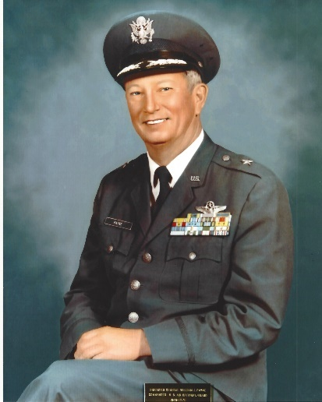

Brigadier General William “Bill” Julius Payne - Achievement

Called the “Father of the North Carolina Air National Guard,” William “Bill” Payne was born in Charlotte NC. He attended Clemson College, graduating in 1938 with a degree in Chemical Engineering. Bill joined the Army Air Corps in 1940 before the U.S. entered WWII, and was assigned to the 52nd Fighter Group in 1942 when he went overseas. First, he flew the British Spitfire in the North African Theater, eventually completing 163 combat missions flying several aircraft, including the P-47 Thunderbolt and the P-51 Mustang. In 1948 he was recruited as military commander of the newly formed NC Air National Guard. Bill was called to active duty during the Korean War with the 123rd Fighter Bomber Group and then subsequently as Deputy Group Commander of the 8th Fighter Bomber Group, and then resumed command of the NCANG, retiring in 1976. His thirty-six year career spanned four decades and three conflicts and he received numerous recognitions, including the Air Medal, a Purple Heart, the Presidential Unit Citation, and ribbons for each conflict: WWII, Korea, and Vietnam. The headquarters building and one of the streets on the NCANG facility are named in his honor.

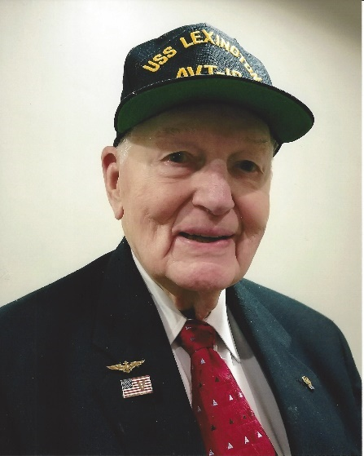

Commander Ralston Murphy Pound Jr - Valor

Ralston Pound was born in Charlotte NC and attended local schools before going to Fisburne Military School in Waynesboro, Virginia. He then attended North Carolina State College for three years before enlisting in the U.S. Navy flight training in September of 1941. Ralston was assigned to Air Group 16 aboard the USS Lexington CV-16 and arrived at Ford Island Naval Base in July of 1943. Participating in raids on the Pacific islands, the Lexington took a torpedo at Truk Atol. He stayed on Mauri while the ship was repaired. Pound then participated in the Mariana’s “Turkey Shoot.” He received the Air Medal for meritorious achievement in the First Battle of the Philippine Sea on 19 June 1944 and received a Distinguished Flying Cross with gold star for actions at Kwajalein and Truk Atols. Ralston also received a Congressional Gold Medal for shooting down six enemy aircraft – making him a Fighter Ace.

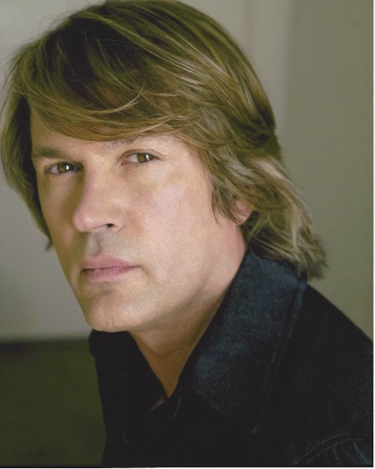

Specialist Rocky “Lynne” Rash - Service

Rockie Lynne Rash was born in Charlotte NC. Rockie Lynne served in the U.S. Army, 82nd Airborne as a Communications Equipment Operator. After serving in the Army, he pursued his love of music by driving to Hollywood in his truck with his meager possessions, which of course included his guitar. After graduating from the Guitar Institute of Technology, he moved all over the country honing his skills. His song “Home: became the theme song featured in a video tribute to honor fallen soldiers. Rockie Lynne then founded the Tribute to the Troops organization, and has helped popularize the non-profit by participating in its activities with musical performances and motorcycle rides. Rockie has made countless national media appearances, including “Good Morning America,” “Fox and Friends,” and appeared in the Associated Press and People Magazine. He has also made numerous appearances on the Grand Ole Opry. Tribute to the Troops has also raised college funds for children of fallen heroes.

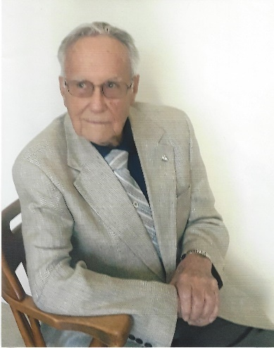

Seaman First Class Arthur Mund Rogers - Service

Arthur Rogers was born in Jamaica, New York. After his service in World War II, he worked as a photographer for the University of California, at which position he had Q-level clearance at Los Alamos, New Mexico. Art’s job called him to take photographs of the mushroom clouds of atomic bomb explosions. On assignment in the Indian Ocean, Art was fifty miles away from an explosion he was photographing when he was severely burned by the 3,000 kiloton blast. He also developed techniques and machines related to photography that helped in FBI cases.

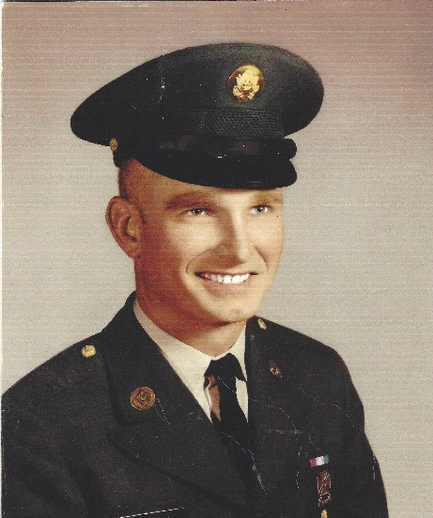

Specialist Coy Lee Thompson - Valor

Coy Thompson was born in Iredell County NC. He served in the U.S. Army, Army of the United States service component, Transportation Corps. Beginning in November 1967, after helicopter training in Virginia, Coy was sent to Vietnam, where he joined the 1st ACFT Main Battalion as crew chief on a UH-1 Huey, which transported troops. He received the Silver Star Medal for rescuing fifty-two men who were trapped by the Vietcong. Because Coy was crew chief, and “it was his ‘copter,” the decision to attempt rescue was given to him by the pilot, who was an officer. Coy also received the Air Medal with two oak leaf clusters for meritorious achievement while participating in aerial flight for the period 18 January to 22 March 1969. Injured in the Tet Offensive, Coy did not receive his Purple Heart until 2015.

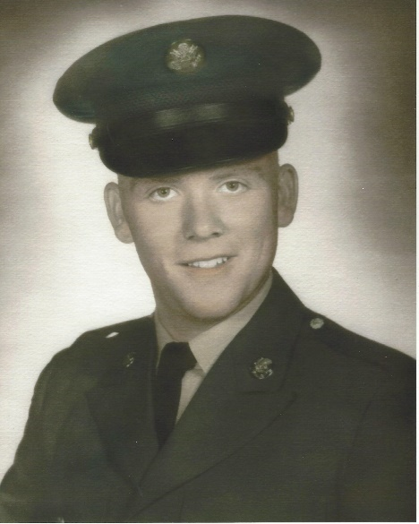

Specialist Ronald Dale Wade - Service

Ronald “Ron” Wade was born in Cabarrus County, NC but lived in Belmont, Gaston County, NC from age twelve. When he turned eighteen, he enlisted in the U.S. Army, arriving in Vietnam to join the 1st Infantry Division at the start of the Tet Offensive. Ron was first wounded in April of 1968 in the Iron Triangle during a midnight rocket attack. In August of the same year, he sustained severe wounds when engaged with a Regiment of North Vietnamese Regulars. Ron was medevaced to Womack Army Hospital at Fort Bragg, where he recuperated for six months and earned his GED. Due to the severity of his injuries, Ron was then assigned stateside for the rest of his time in service. The following years included many doctor appointments, back surgery, and therapy. When the Military Order of the Purple Heart chapters began a national challenge to make all states “Purple Heart States,” Ron became inspired by the idea and rose to the challenge. His Chapter 634 was instrumental in making North Carolina the first Purple Heart State in the nation. Ron currently serves as Senior Vice Commander of the Purple Heart Chapter 634.

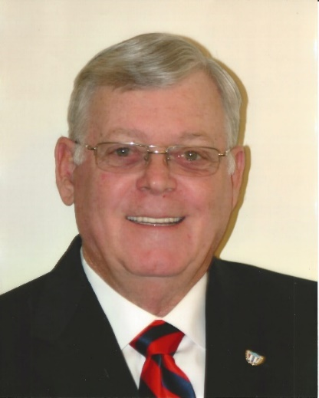

Major Jerry Troy Walden - Valor
Jerry Walden was born in Monroe NC and devoted twenty-one years of service to the U.S. Army, earning the Distinguished Service Cross, the Silver Star Medal, the Bronze Star Medal, a Purple Heart, the Legion of Merit, three Meritorious Service Medals, the Air Medal, the Army Commendation Medal, a Valorous Unit Award, and a Presidential Unit Citation. Jerry received the Distinguished Service Cross for extraordinary heroism in armed combat. He was serving as platoon leader for Delta Company, 3rd Battalion, 187th Infantry Battalion, 101st Airborne Division during the assault on Dong Ap Bias Mountain (Hamburger Hill) on 18 May 1969. He assumed command when the commanding officer fell and the company took the hill, although they suffered 50% casualties. Jerry was wounded in the leg by shrapnel. Still under intense fire, Walden took several hand grenades and assaulted enemy positions. After knocking out four bunkers, he was seriously wounded by an enemy grenade. He assessed the company’s situation and ordered a withdrawal, during which he was wounded in the arm by sniper fire. He crawled down the hill, pulling a wounded man to safety. He refused evacuation until a replacement officer arrived. His devotion to duty reflects great credit upon himself and his unit.

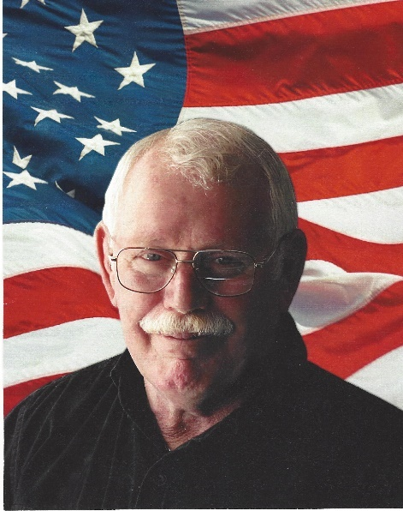

Chief Warrant Officer Two Richard Eugene Warren - Service

Richard Warren was born in Champaign, Illinois. He served in Vietnam as a Chief Warrant Officer and a pilot with the 68th Attack Helicopter Company, flying the Bell UH-1 Huey from 1969 -70. Richard first flew troops and then transferred to gunships. Many times he had to come in to rescue U.S. troops surrounded by the enemy. Stationed in Germany after his tour in Vietnam, Richard transported Generals in his helicopter. After his service, Richard and his wife moved to Mooresville NC and opened a coffee shop. Seeing a veteran who was unable to afford a cup of coffee, Richard decided to have a day to offer veterans free coffee. Soon the veterans began to bring in photos and other military memorabilia and Richard decorated the walls of the coffee shop with the veterans’ offerings. Warren has a heart to give Vietnam veterans the warm “Welcome Home” they didn’t receive at the end of the war. He devoted all his energy and resourced to welcoming ad helping veterans who came into the shop, and Richard’s Coffee Shop has since become an institution in Mooresville.

